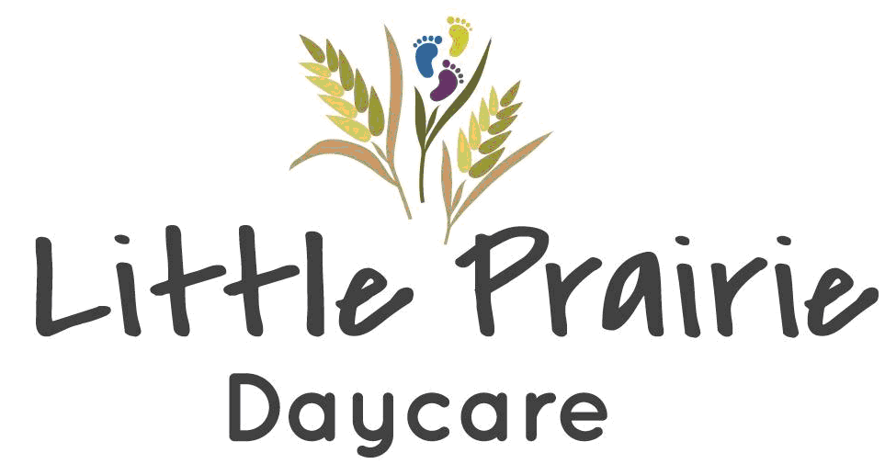

After School Program Enrollment Form

If mutiple children enrolled, please fill out a sperate form for each child.

Child’s Name: ___________________________ Child’s Age: ___________

Birthdate: ________________________

Mailing Address: ____________________________

Physical Address: ___________________________________

City:__________________________ Postal Code: ______________

Parent/Guardian

Name: ________________________________

Address (if different than child’s):
Mailing & Physical Adress: __________________________________

City: _____________________ Postal Code: _________________

Emergency Contact

Name: ______________________________

Address: ____________________________

Phone: ________________________ Alternate Phone:______________________

Relationship to child: __________________________

RATE: $12/day per child.

REGISTRATION: Please see the After School Program Registration Tab on http://www.littleprairedaycare.ca/

Please email the dates you would like to send your child to luckylakedaycare@gmail.com with the month and After School Program in the subject area. Please note that the After School Program does NOT run on non-school days, PD days, school breaks, and weekends.

You must have your dates for the next month in by the 11th of the month previous. You will need to pre-pay for the month ahead by the 1st of each new month. E-transfer to luckylakedaycare@gmail.com

STUDENT PICK-UP: You must check your child out of the After School Program. Please enter only through the doors nearest the staff/student parking lot. The After School Program room is in the playschool room at Lucky Lake School. If you will be picking them up prior to 5:30, please indicate on your months registration forms if you know in advance. If needed, you may text or call the After School Program cell-phone.

CONTACTING THE AFTER SCHOOL PROGRAM: If you need to get a hold of the After School Program Leaders, please do so by using the phone number for the After School Program cell-phone. This will be communicated as soon as it is set up. Please do not contact the school.

COVID-19 PROTOCOLS: We will be following all current guidelines for COVID-19. Please do not hesitate to contact the daycare at (306)858-9119 or luckylakedaycare@gmail.com if you require clarification.

DECLARATION

I have read the above and agree to all points included. All information provided in this registration form is true and complete. I will maintain current information with the program and any changes in place of residence, place of employment, home and/or work telephone numbers, persons having access to the children, emergency contact persons, etc., will be reported promptly.

Date: ____________________ Initial: ______________

Little Prairie Daycare is not responsible for children's personal items that are damaged, lost or stolen.

Date: ____________________ Initial: _______________

Parent Handbook

I have read the contents of the Parent Handbook Information and agree to comply with the regulations and and policies of the Little Prairie Daycare. If there are any issues or concerns I will contact the Director and schedule a meeting if necessary.

Date____________________ Initial: _________________

Parent/Guardian Signature: ____________________ Date: ____________

Signature of Witness: ______________________________

